Nightingale 72-Hour Build technical report
Chen Xinyue
Email: S260058@e.ntu.edu.sg
1. Project introduction
Nightingale is a convenient medical record collaboration system based on Flask, which supports login and information viewing for three roles: patients, doctors, and nurses, facilitating doctors and nurses to view and update patients' diagnostic information in real time.
2. System Structure
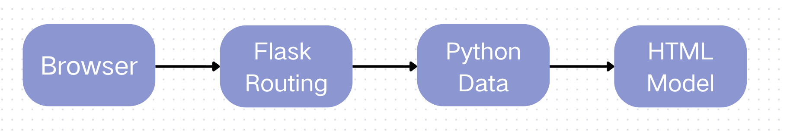
This system adopts the flask framework and is divided into three layers:
1. Routing layer: receives user requests and decides which function to execute
2. Logic layer: processes data and verifies user identities
3. Data layer: use python dictionaries to store patient data
Data flows from the back end to the page, and what users see is the rendered HTML.

3. Technology Stack
Backend: Flask (Python)
Frontend: HTML + CSS (inline styles)
Data Storage: Python dictionaries (in-memory storage)
Deployment: Localhost on port patient: 5001/ doctor: 5002/ nurse: 5003

4. Routing Design
/login: dealing log in
/patient: the page for patients
/doctor: the page for doctors
/nurse: the page for nurses
/logout: log out

5. Visible Page
Patient Page
- Patient Story
- Doctor Diagnosis
- To Do list from nurse Instructions (e.g., pick up medication, blood test, CT scan)
Doctor Page
- Patient Story
- AI Suggestion
- Upload Diagnosis
- Introduction from nurse
Nurse Page
- Patient Story
- AI Suggestion
- Doctor Diagnosis
- Upload Instructions for Patient

6. Disadvantages
- The AI message section is fictional and does not incorporate any actual large language models
- The patient page should not allow viewing of the identity information of other patients.
- When the patient completed the instructions given by the nurse, there was no indication of this. Neither the nurse nor the doctor knew whether the patient had completed the task

